Maven Project 🡪 Run Spring Boot 🡪 FBOAce04aApplication

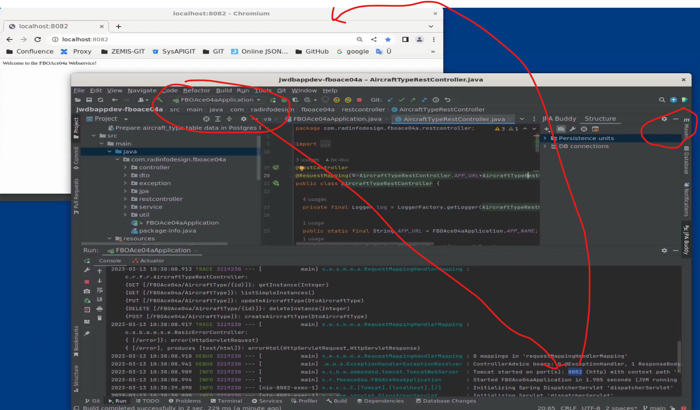

Maven Project 🡪 Must be selected.

